|  |  |  |  |  |  |
| --- | --- | --- | --- | --- | --- |
| **Policy Title:** | **Break Glass Policy** |  | **Policy Number:** | **HIM30001** | |
| **Departments:** | All |  | **Effective Date:** | June 2010 | |
| **Reviewed/ Revised Date:** | October 2011, October 2012 | | | | |
| **Approval:** | Cathi Fontenot, M.D. - Chief Executive Officer | | | |
| **Approval:** | Sharon Rives - Chief Financial Officer | | | |

|  |  |
| --- | --- |
|  |  |

**Purpose:** To assess the appropriate level of access to the EHR via document security and user roles.

**Policy:** LSU Healthcare Network’s (LSUHN) electronic health record (EHR) shall be treated in a confidential manner and accessed only for appropriate purposes. LSUHN recognizes the variation of user roles, privileges, and restrictions regarding the EHR. Therefore, LSUHN shall establish document security requirements for faculty, staff, residents, and students regarding access to the EHR.

**Procedure:** Viewing Secure Documents

Viewing security allows certain patients’ health information to be visible only to designated users.

*Break Glass* is a security code that allows users to access patient accounts under viewing security upon supplying a password. Users who do not have viewing security rights to view these accounts will have to “break glass.”

1. At the time a user accesses a patient’s account to which they do not have viewing security rights, the user will be prompted with a warning screen.

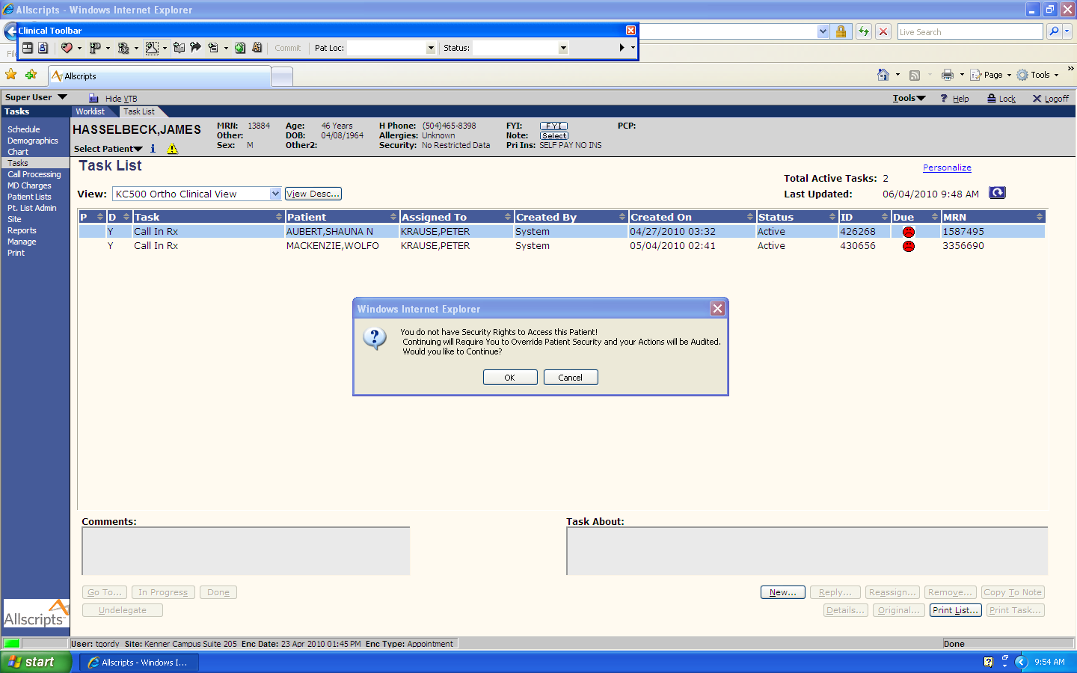

1. If the user chooses to continue, a Patient Security Confirmation screen will appear.

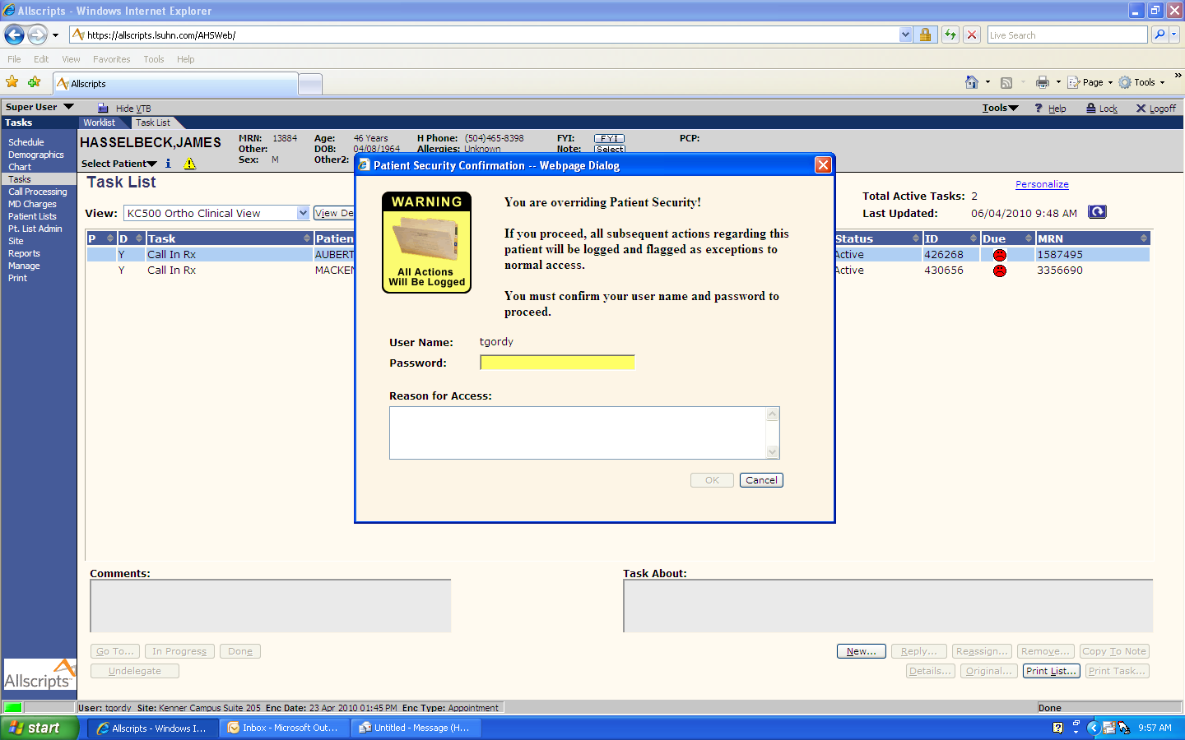

1. The user must type in their password and reason for accessing the patient’s record. The user must provide a valid reason for accessing the information such as scheduling an appointment or triaging the patient.
2. The EHR will allow the user to “break glass” and access the patient’s record.

The EHR tracks all documents the user accessed, edited, and the length of time spent in each document.

Monitoring Break Glass Policy

1. Designated personnel will run a monthly break glass report and deliver to the compliance department for review.
2. Compliance department will monitor break glass report on a monthly and as needed basis.
3. Compliance department will work with administration, HIM department and clinic directors to educate staff and enforce the “Break Glass” Policy.

Break Glass Confidentiality Agreement

Users who do not have the security access to view secure documents will be asked to sign a Break Glass Confidentiality Agreement. (See attachment)

Violation of Break Glass Policy

LSUHN will appropriately discipline employees who fail to comply with the Break Glass Policy.

Violations shall be addressed through the LSUHCN Human Resources Disciplinary Policy, HR-17, and may include the following sanctions:

Verbal Warning /Written Warning

Suspension for 5 Working Days

Termination

Sequential sanctions are not mandatory. LSUHN maintains the authority to decide which sanction most effectively addresses the severity of the violation.

**Attachment:** Signature Attestation



**Break Glass Policy**

**Scope**

This policy establishes requirements for staff, faculty and students regarding access to LSU Healthcare Network information as well as the responsibilities for stewardship of LSU Healthcare Network information. LSU Healthcare Network information is all information generated or acquired, in printed or machine-readable form, by LSU Healthcare Network faculty, staff, students, contractors or others engaged on the LSU Healthcare Network’s behalf, in the course of carrying out the LSU Healthcare Network’s mission or conducting its patient care.

**Policy Statement**

LSU Healthcare Network shall be used only in appropriate purposes. Information is a resource analogous to Network financial and physical resources. All members of the Network community should be aware of their obligations to protect Network information. In particular:

* Network information may not be accessed by or disclosed to anyone who does not need the information to perform the activities and fulfill the responsibilities associated with his or her Network position.
* Those accessing Network information are responsible for giving a password and reason for entering a secured chart.
* Entering Network secured charts without entering the required information will be regarded with utmost seriousness. Alleged violations of this policy will be pursued in accordance with the appropriate disciplinary procedures for faculty, staff and students, and when indicated, sanctions up to and including dismissal will be imposed.

By signing this document, you are acknowledging that you have read and understand LSU Healthcare Network’s Break Glass Policy.

Printed Name: ____________________________________________________

Signature: _______________________________________________________

Date: ___________________________________________________________